**Python Class:**

Pre-Requisite

1. Suitable for beginners (without programming knowledges)
2. Install Anaconda from [Anaconda | The World's Most Popular Data Science Platform](https://www.anaconda.com/)
3. Install Visual Studio Code ([Visual Studio Code - Code Editing. Redefined](https://code.visualstudio.com/))
4. Python IDE (<https://www.python.org/downloads/>)

Why Use Anaconda

* Ease of installation and configuration
* Easy to see data and output from graph & excel file

Other Alternatives than Anaconda (require less space in the system)

* Google Colab (<https://colab.research.google.com/?utm_source=scs-index>)

Getting Start with Anaconda

After Installation, Search for Anaconda Navigator: (Run as Administrator)



Launch Spyder:

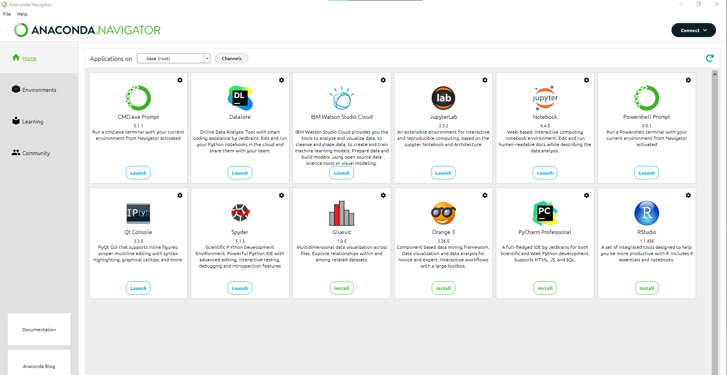

Initialization:



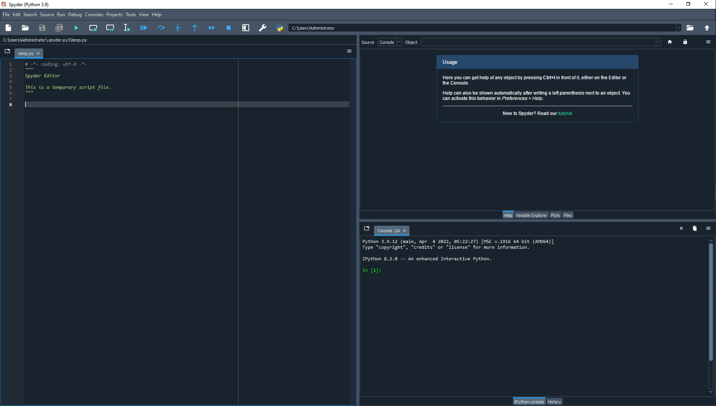

In case not working: Run > Configuration per file > Execute in an external system terminal

Getting Start with VS Code

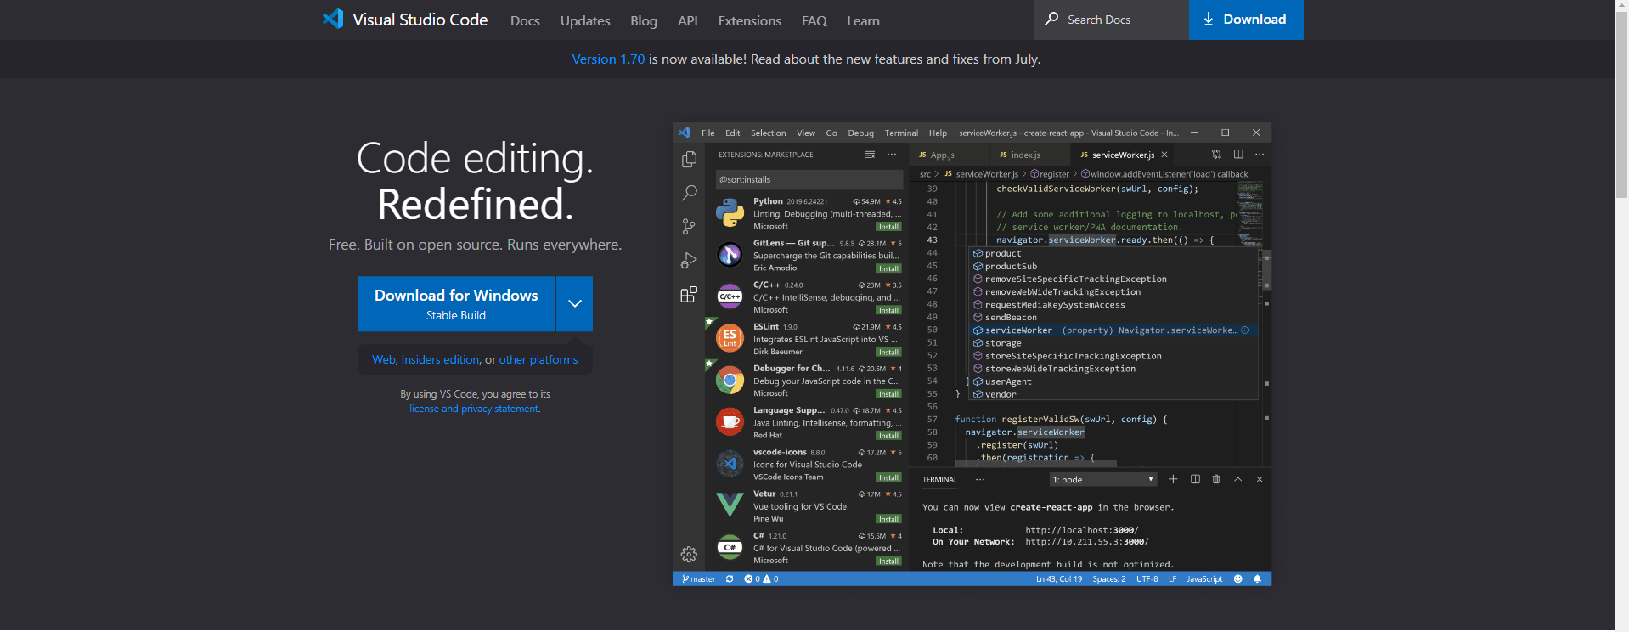

* Accept the agreement and click “Next”
* Choose where you want to install the Visual Studio Code and click “Next”
* Select start menu folder and click “Next”

Tick the additional tasks as below and click “Next”

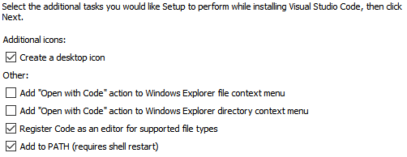

And install it!!!

Then install Python at: (<https://www.python.org/downloads/>)

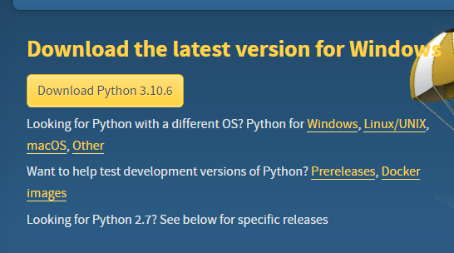

Select Add Python 3.10 to Path & “Install Now”

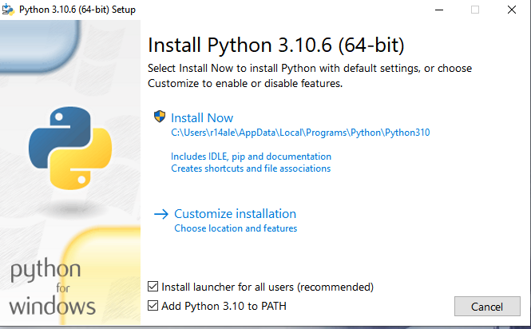

Open Visual Studio Code and “Select Interpreter” after finish installing Python



Select the Python that you had just installed

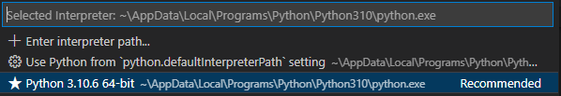

Once Interpreter selected



Now you are good to go for the lesson 1.

**Python Cheat Sheet**

**Main Rule**

Indentation refers to the spaces at the beginning of a code line.

Where in other programming languages the indentation in code is for readability only, the indentation in Python is very important.

if 5 > 2:  
  print("Five is greater than two!") - OK

if 5 > 2:  
print("Five is greater than two!") - Syntax Error

**Variable Name**

A variable can have a short name (like x and y) or a more descriptive name (age, carname, total_volume). Rules for Python variables:

* A variable name must start with a letter or the underscore character
* A variable name cannot start with a number
* A variable name can only contain alpha-numeric characters and underscores (A-z, 0-9, and _ )
* Variable names are case-sensitive (age, Age and AGE are three different variables)

Variable’s Data Type

|  |  |  |
| --- | --- | --- |
| Example | Data Type | Remarks |
| a = “Hello World” | str | String |
| a = 5 | int | Integer |
| a = 5.0 | float | Float |
| a = 5j | complex | Complex |
|  | list |  |
|  | Tuple |  |
|  | Range |  |
|  | set |  |
|  | Bool |  |
|  | Bytes |  |
|  | NoneType |  |

Comments – Comments start with a #

Will not be displayed at the Output, only for your reference

#This is comment

print(“Hello World”)

Python built in function to print/display the output

**Python Assignment Operators – Assign values to variables**

|  |  |  |  |
| --- | --- | --- | --- |
| **Operator** | **Example** | **Same as** | **Remarks** |
| **=** | **x = 5** | **x = 5** | **x is 5** |
| **+=** |  |  |  |
| **-=** |  |  |  |
| **\*=** |  |  |  |
| **/=** |  |  |  |
| **%=** |  |  |  |
| **//=** |  |  |  |
| **\*\*=** |  |  |  |
| **&=** |  |  |  |
| **|=** |  |  |  |
| **^=** |  |  |  |
| **>>=** |  |  |  |
| **<<=** |  |  |  |

**Python Arithmetic Operators – Perform Common Mathematical Operations**

|  |  |  |
| --- | --- | --- |
| Operator | Name | Example |
| + | Addition | x + y |
| - | Subtraction | X - y |
| * | Multiplication | x * y |
| / | Division | x / y |
| % |  |  |
| ** |  |  |
| // |  |  |

**Python Comparison Operators – Used to compare two values**

|  |  |  |
| --- | --- | --- |
| **Operator** | **Name** | **Example** |
| **==** | **Equal** | **x == y** |
| **!=** |  |  |
| **>** |  |  |
| **<** |  |  |
| **>=** |  |  |
| **<=** |  |  |

**User Input**

|  |  |
| --- | --- |
| **Method 1** | **Name = input(“What is Your Name : “)** |
| **Method 2 (Expected input in int)** | **age = input(“What is Your Age : “)**  **age = int(age)** |
| **Method 2a (Expected input in int)** | **age = int(input(“What is Your Age : “)** |

#This is a comment

#Variable Naming

# A variable name must start with a letter or the underscore character

# A variable name cannot start with a number

# A variable name can only contain alpha-numeric characters and underscores (A-z, 0-9, and _ )

# Variable names are case-sensitive (age, Age and AGE are three different variables)

#  1.0  Data Types

#String

greet =  "Hello World"

#To check the data type & display output

print(type(greet))

#Integer

#Try to check the datatype

number = 1

#Float

#Try to check the datatype

float_number = 5.0

#Complex Number

#Try to check the datatype

complex_number = 1+3j

# 1.1 Assigning Operator

x =  5

## What is the value of x? Try to print out and check the results at terminal

# 1.2 Arithmetic Operator

## What is the value of c,d,e,f? Try to print out and check the results at terminal

a = 4

b = 2

c =  a+b

d =  a-b

e =  a*b

d =  a/b

## Try to use other arithmetic operator %, **, // on y&z and check the results at terminal

y = 3

z = 2

## Can we do more advance calculation which involved more than 2 numbers, or different datatype (int & float), try it out!!!

# 1.3 Input data

name = input("Enter Your Name")

age = input("What is your age? ")

## How to accept only int as the format for age?